Amateur radio is one of those hobbies where there is always something new to do or to learn. And if you like challenges, there is always a new challenge. It may be working that rare DX, increasing one’s contest score, operating from a remote hilltop, or participating in a far-flung DX-pedition.

One of the challenges I enjoy is working towards amateur radio awards, of which there are hundreds[1].

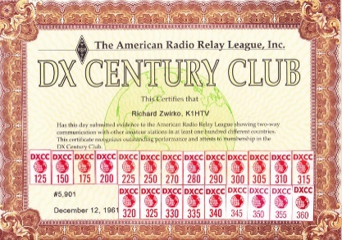Perhaps the best-known HF awards programme is the ARRLs DXCC, requiring a minimum of 100 confirmed DXCCs for the basic award. Achieving confirmed QSOs with all 340 current DXCC entities on the current DXCC entities list represents a considerable achievement. This certificate belongs to K1HTV who has worked 360 entities (including deleted).

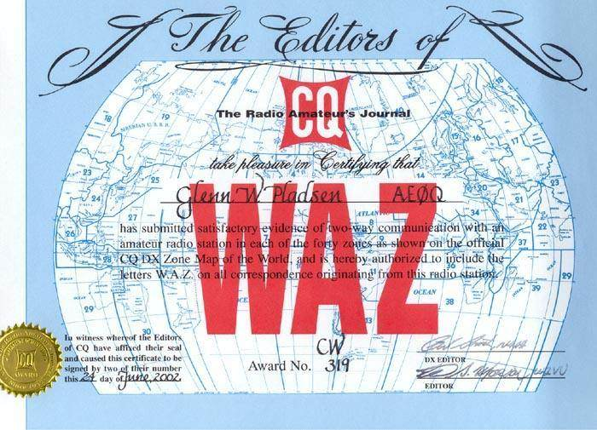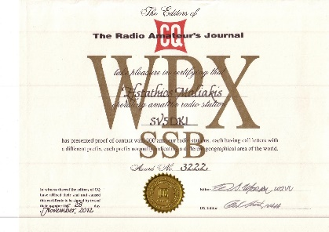CQ Magazine also offer several awards, including WAZ (Worked All Zones) and WPX (Worked Prefixes). While single band or single mode WAZ may not be that difficult to achieve, the 5 band versions provide a greater challenge. For WPX, the entry requirements are relatively easy (for example 300 different prefixes for the basic CW, SSB or Data award), but the WPX Award of Excellence is much more of a challenge and requires 1000 confirmed prefixes in Mixed mode and 600 prefixes in SSB and 600 prefixes in CW plus all 6 continental endorsements and the 5 non-WARC band endorsements. Looking at the WPX Honor Roll listing, WA2HZR currently has confirmed 7054 unique prefixes on CW, W3LL has 2481 unique digital prefixes and OZ5EV has 6573 unique SSB prefixes – one needs a lot of QSOs to achieve this number of unique prefixes. It is helpful that the CQ awards can use both LotW or eQSL confirmations.

While ARRL’s DXCC and the CQ magazine awards are probably the best known of all the HF award programmes there are many other awards offered by amateur radio organizations around the world including eQSL[2]. Some awards can be quite difficult to achieve, others are much easier. The certificates usually cost only a couple of dollars or Euros – and in many cases are free as downloads; they are usually prettily designed and look great on the shack wall – they certainly impress visitors.

Examples of awards I’ve found interesting to work towards or achieve include:

* 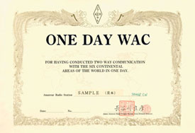JARL’s one-day WAC; work all continents in one day. If you have a mega-station then it isn’t difficult to achieve. I was delighted when I achieved it running 50 watts of RTTY into a homemade multi-band dipole – and the certificate looks great on the wall;
* DARC’s EU28A award[3] – worked all 28 members of the European Union – with band / mode endorsements available. Not particularly difficult from the UK although a requirement is to have worked 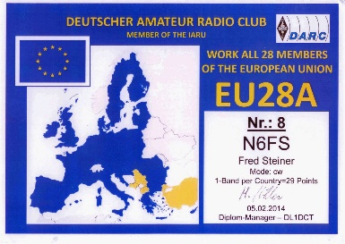the Council of Europe station (TP prefix) which doesn’t seem to be operational very often. DARC offer a wide range of awards[4], many of which are Euro-centric and managed through the DARC Community Logbook;
* DARC also offer the Worked All Europe Award (WAE). The WAE Class I award requires confirmed QSOs with all 73 countries in Europe and includes 1A, 4U1V, JW/B and R1FJ which aren’t activated that often;
* The Deutschland-Diploma (DLD) offered by DARC is based on collecting DOKs (District Location Codes). Collecting the first 100 DOKs for the basic award is reasonably easy, but despite the number of German stations operating, achieving the top level of 1000 DOKs looks a lot more difficult.
* 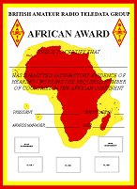As a committee member of the British Amateur Radio Teledata Group I feel obligated to mention their awards. BARTG[5] offer six separate all-RTTY continent awards, a Quarter Century Award (25 countries worked using RTTY, in increments of 25) and a PSK31 award – all for a few of pounds;
* The RSGB administers a number of HF[6] and VHF[7] awards. Over the years I have collected several of the VHF awards – 50MHz Countries and Squares awards and 70MHz, 144MHz and 432MHz squares / countries awards where one needs to have confirmed QSOs with a specified number of countries and squares per band to be eligible for the award. There are many award levels, each of which reflects an increasing operating challenge, especially for VHF / UHF if you operate from a valley!

The RSGB administers several HF awards. These include the:

* IARU Region 1 Award; three levels of award: Class 3 – 40 member countries; Class 2 – 60 member countries; Class 1 – all 97 member countries; with various endorsements available for band and mode.
* 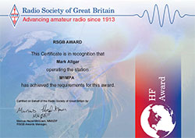Commonwealth Century Award. There are, perhaps surprisingly, a total of 139 Commonwealth Call areas and the award has three levels: Bronze – 40 Commonwealth call areas; Silver – 70 call area; Century – 100 call areas; with various endorsements available for band and mode.
* Worked ITU Zones Award. There are 75 ITU zones, with the basic award requiring confirmed QSOs with 70 zones. There is also a 5 Band ITU zone award as well as WARC band and Top Band endorsements.
* Worked All Continents Award. The basic award requires confirmed QSOs with the six continents – Europe, Africa, Asia, Oceania, North America and South America, with endorsements available by band and by mode. There is also a 5-band award, which for a small station can be more of a challenge!
* specific HF awards for Foundation Licences (40 / 70 / 100 contacts across 40m, 20m, 17m and 2m) and Intermediate Licences (100 contacts across 80m, 40m, 30m and 17m).

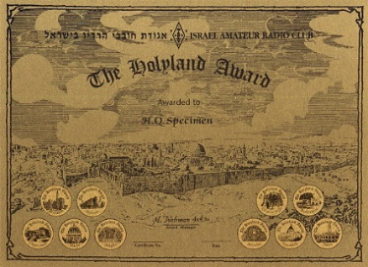I recently decided to apply for the RSGB’s Commonwealth Century Award (basic Bronze level). The application is remarkably easy. A spreadsheet is downloadable from the RSGB’s website. This lists all the Commonwealth call areas, organized by continent. The spreadsheet requires Callsign, date of QSO and band, plus the LotW Unique ID, if applying using LotW confirmed contacts. QSL cards may be used and can be scanned and emailed or posted to the RSGB Awards Manager (currently being appointed) for authentication. A simple application form is required showing the award applied for. This can either be posted, together with the spreadsheet, or emailed – the email version requiring a simple digital signature. My application was processed within two days, with a very nice certificate arriving in the post within the week. The cost of the application was just £3.50 for a paper certificate (£2.50 for an electronic certificate; £5.00 for both electronic and paper).

* The Israel ARC offer a Holy Land award. For this award the country is divided in to regions (23) and 10 x10 km squares. The basic award for amateurs in Region 1 requires confirmed QSOs with 100 areas from a minimum of 13 regions;
* 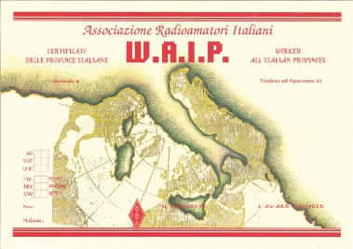The Italian ARS[8] offer a huge number of awards, such as the Worked All Italian Provinces award. There are 110 provinces; amateurs living outside Italy require a minimum of 60 different provinces for the basic award.

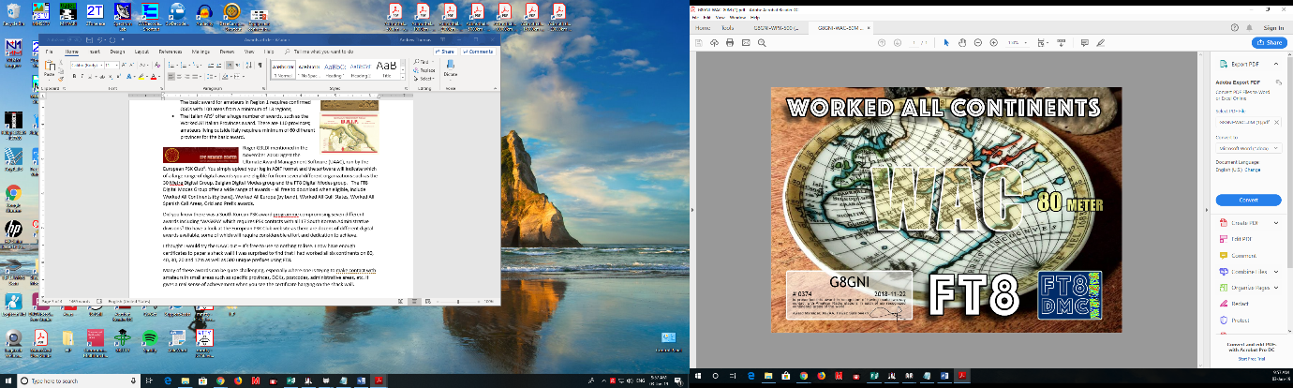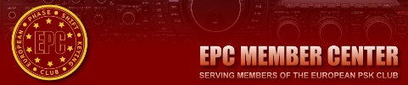Roger G3LDI mentioned in the November 2018 Digest the Ultimate Award Management Software (UAAC), run by the European PSK Club[9]. You simply upload your log in ADIF format and the software will indicate which of a large range of digital awards you are eligible for from several different organizations such as the 30 Metre Digital Group, Belgian Digital Modes group and the FT8 Digital Modes group. The FT8 Digital Modes Group offer a wide range of awards – all free to download when eligible, include Worked All Continents (by band), Worked All Europe (by band), Worked All Gulf States, Worked All Spanish Call Areas, Grid and Prefix awards.

I thought I would try the UAAC out – it’s free to use so nothing to lose. I now have enough certificates to paper a shack wall! I was surprised to find that I had worked all six continents on 80, 40, 30, 20 and 17m as well as 500 unique prefixes using FT8.

Did you know there was a South Korean PSK award programme compromising seven different awards including ‘WASKPA’ which requires PSK contacts with all 17 South Korean Administrative divisions? Do have a look at the European PSK Club website as there are dozens of different digital awards available, some of which will require considerable effort and dedication to achieve.

Looking at amateur’s web sites and QSL cards it is interesting to note the emphasis on DXCC and WAZ. Achieving DXCC Honor Roll or 5 band WAZ is clearly a major achievement, but there are other awards that present a different set of challenges, especially where one is trying to contact amateurs in small areas such as specific provinces, DOKs, postcodes, administrative areas, etc. It gives a real sense of achievement when you see the certificate hanging on the shack wall.

Whilst continuing to slowly add to my DXCC and WAZ total I’m currently focusing on the Worked All Italian Provinces Award – 45 provinces so far.

These are just a few of the hundreds of awards that are available – some relatively easy to achieve, others much more difficult and requiring tenacity, patience and probably a bit of luck. If you are looking for another amateur radio challenge, or a little more motivation to get on the air, then why not try working towards one or more of the many awards that are available?

Andrew G8GNI

1. <https://www.qsl.net/va3rj/awards_dx.html> (Note that many of the links on this website are out of date)
2. <https://www.eqsl.cc/qslcard/Index.cfm>
3. <http://dcl.darc.de/~dcl/public/diplom_details.php?diplomid=99>
4. <http://dcl.darc.de/~dcl/public/diplome.php>
5. <http://bartg.org.uk/wp/bartg-datamode-awards/>
6. <https://rsgb.org/main/operating/amateur-radio-awards/rsgb-hf-awards/>
7. <https://rsgb.org/main/operating/amateur-radio-awards/vhfuhf-awards/>
8. <http://www.ari.it/>
9. <https://www.eupsk.com/index.php?option=com_content&view=article&id=8&Itemid=112>